39.63: a) The ball is in a cube of volume 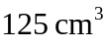 to start with, and hence has an uncertainty of 5 cm in any direction. 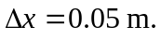(The x-direction in the horizontal, side-to-side direction.)
Now 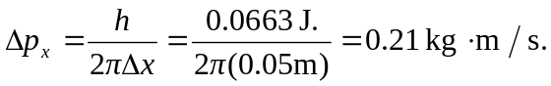
b) The time of flight is 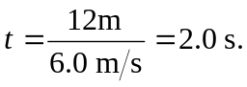
So the uncertainty in the x-direction at the catcher is
